`  *PREFACE*

*Programming languages, paradigms and practices don’t stand still very long. It often seems that the methods and techniques we applied yesterday are out of date today of course this rapid rate of change is also one of the things that keep programming existing.*

*There is always something new on the horizon. One characteristic that is constant in software industry today is the “change”. Change is one of the most critical aspects of s/w development and management. New tools and new approaches are announced almost everyday. The impact of these development is often very extensive. Most important among them is maintaining ability, reusability, portability, security, integrity and user friendliness.*

*To build today’s complex software we need to wound construction techniques and program structures that are easy to comprehend, implement and modify in wide variety of situations.*

*ACKNOWLEDGEMENT*

*We get immense pleasure to owe our sincere gratitude to all who helped us in doing this project. We especially thank the ‘WampServer’ & the ‘Navicat for MySQL Softwares,’ ‘html’. Without the help of these software perhaps this project would have remained failure.*

*We also thank our H.O.D Sir for his keen and consistent guidance, which has served as a beacon in the preparation of this project.*

*Next our heartfelt gratitude is to our parents for their unfailing support and encouragement in our every step.*

*And then at last but not the least, we acknowledge our being indebted friends without whose help and assistance this project would not have seen the light of the day.*

-

*CErtificate*

*This is to certify that Arpanjyoti Parasar and Sudeep Bhardwaj of BCA 6th semester from Jagannath Barooah College, Jorhat have successfully completed this project entitled ”Tocklai Publications Management ” under my supervision and guidance as part of the assignment to be completed under the BCA 6th semester course*

*Date: Internal Examiner*

*Place: Jorhat* *Department of Computer Science*

*Jagannath Barooah college, Jorhat*

*TABLE OF CONTENTS*

***CHAPTER 1: INTRODUCTION***

*1.1 Background*

*1.2 Objective*

*1.3 Purpose, Scope and Applicability*

*1.3.1 Purpose*

*1.3.2 Scope*

*1.4 Achievements*

*1.5 Organization of Report*

***CHAPTER 2: SURVER OF TECHNOLOGY***

***CHAPTER 3: REQUIREMENTS AND ANALYSIS***

*3.1 Problem Definitions*

*3.2 Requirement Specifications*

*3.3 Software and Hardware Requirements*

*3.3.1 Hardware Requirements*

*3.3.2 Software Requirements*

*3.4 Preliminary Product Description*

*3.5 Conceptual Models*

*3.5.1 Module Specifications*

*3.5.2 Screen Views*

*3.5.3 Data Flow Diagrams*

***CHAPTER 4: SYSTEM DESIGN***

*4.1 Basic Modules*

*4.2 Data Design*

*4.2.1 Schema Design*

*4.2.2 Data Integrity and Constraints*

*4.3 Procedural Design*

*4.3.1 Logic Diagrams*

*4.4 User Interface Design*

*4.5 security Issues*

***CHAPTER 5: IMPLEMENTATION AND TESTING***

*5.1 Implementation Approaches*

*5.2 Coding Details and Coding Efficiency*

*5.2.1 Coding*

*5.2.2 Code Efficiency*

*5.3 Testing Approach*

*5.3.1 Unit Testing*

*5.3.2 Integrated testing*

*5.4 Modifications and Improvements*

***CHAPTER 6: RESULTS AND DISCUSSION***

*6.1 Test Reports*

*6.2 User Documentation*

***CHAPTER 7: CONCLUSION***

*7.1 Conclusion*

*7.2 Limitations of the System*

*7.3 Future scope of the Project*

***CHAPTER 8: BIBLIOGRAPHY***

***1. INTRODUCTION***

*The goal of this master's project is to design an publications management mainly sells publications produced by Tocklai Tea Research Institute. The publications inventories are stored in database. User can access the system web site through the World Wide Web. User will be able to search the database to find the publications they want, check the availability, and sell them to the customer through hand to hand.*

***1.1 Background***

*Tocklai Publications Management is the application of web based technologies to provide several details of publications.*

***1.2 Objective***

*The objective of the project is to develop the system that automates the processes and activities of Tocklai Publications Management system.*

*The purpose is to design a system using which one can perform all operations related to Tocklai Publication Management system.*

***1.3 Purpose and scope***

***1.3.1 Purpose***

*The purposes of the Tocklai Publication Management are:*

* *Provide a user interface to store the details of the publications.*
* *Provide a user interface for User to view the list of books and choose the books they need.*
* *Provide a user interface for the user to register and sell publications.*
* *Provide a user interface for administrator to manage the records such as to add, view (delete and edit) books and also manage the database.*

***1.3.2 Scope***

*The main scope and deliverables of the project would be to:*

* *Understand and prepare detailed requirement and specifications.*
* *Prepare high level and detailed design specifications of the system.*
* *Prepare Test Plan and Test cases.*
* *Develop the system and coding*
* *Perform unit testing, integration and system testing.*

***1.4 Achievements***

***1.5 Organization of Report***

*This report is organized in seven chapters as indicated in the Table of Contents. These chapters deal with the important aspect of the System Development Cycle. Each of the chapters is divided into Headings and Sub Headings. Chapter 1 introduces the project its background and purposes. The technologies used in the project and the reason of thereof are explained in chapter 2. Chapter 3 broadly deals with the requirements, analysis and planning of the project. All the design, security and test cases. The actual implementation has been discussed in Chapter 5, which includes coding and testing of the working of the system. Chapter 6 discusses the test reports and project documentation and finally the conclusions have been drawn in Chapter 7. At the end of the report, the references made and the glossary has been included.*

*We have devised the following modules according to the requirements of the organization. They are 1) Administrator Module 2) User Module. Administrator has the whole authority of the organization. He is the one who maintains all the aspects of records. His functionalities include insertion, updation and deletion of records. He is responsible for allowing person to buy books. Users have the provision to view the list of books and order the desired book.*

*Tocklai Publications management is a software application which maintains records of the publications and the buyers. This software is designed for booking purpose which saves lot of time*

***2. SURVEY OF TECHNOLOGY***

*In a web based application like Tocklai Publications Management, there is a scope for a large number of platforms, languages, web servers and frameworks to choose from. Before selecting from this large array of technologies, the following aspects which are characteristic to web based applications like this one, have been kept in mind.*

* *Dynamic page generation*
* *Data validation*
* *Performance*
* *Reliability*
* *Scalability*
* *Security*
* *Portability*
* *Performance*
* *Time constraint*
* *Cost constraint*

*The various technologies available for consideration are as follows:*

***Operating System: Windows 7***

***Client side Scripting:***

* ***HTML***
* ***CSS***
* ***JavaScript***

***Server Side Scripting: PHP***

***Database Tool: My SQL***

***Testing Server: Apache***

***Other Software Used:***

* ***Adobe Dreamweaver***
* ***Adobe Photoshop***
* ***Wamp Server***

***HTML:***

*HTML or HyperText Markup Language is the standard markup language used to create web pages.*

*HTML is written in the form of HTML elements consisting of tags enclosed in angle brackets (like <html>). HTML tags most commonly come in pairs <h1> and </h1>, although some tags represent empty elements and so are unpaired, for example <img>. The first tag in a pair is the start tag, and the second tag is the end tag (they are also called opening tags and closing tags).*

*The purpose of a web browser is to read the HTML documents and compose them into visible or audible web pages. The browser does not display the html tags, but uses the tags to interpret the content of the page. HTML describes the structure of a website semantically along with cues for presentation, making it a markup language rather than a programming language.*

*HTML elements form the building blocks of all websites. HTML allows images and objects to be embedded and can be used to create interactive forms. It provides a means to create structured documents by denoting structural semantics for text such as headings, paragraphs, lists, links, quotes and other items. It can embed scripts written in languages such as JavaScript which affect the behaviour of HTML web pages.*

***CSS:***

*CSS was first developed in 1997, as a way of Web developers to define the look and feel of their web pages. It was intended to allow developers to separate content from design so that HTML could perform more of the functions that it was originally based on the markup of content, without worry about the design and layout.*

*CSS didn’t gain in popularity until around 2000, when Web Browsers began using more than the basic font and colour aspects of CSS>*

*Web Designers that don’t us CSS for their design and development of Web sites are rapidly becoming a thing of the past. And it is arguably as important to understand CSS as it is to know HTML and some would say it was more important to know CSS.*

*Style sheet refers to the document itself. Style sheets have been used for document design for years. They are the technical specification for a layout, whether print or online. Print designers use style sheets to insure that their designs are printed exactly to specifications. A style sheet for a Web page serves the same purpose, but with the added functionality of also telling the viewing engine (the Web Browser) how to render the document being viewed.*

***PHP:***

*PHP (recursive acronym for PHP: Hypertext Preprocessor) is a widely-used open source general purpose scripting language that is especially suited for development and can be embedded in HTML.*

*Instead of lots of commands to output HTML, PHP pages contains HTML with embedded code that does “something”. The PHP is enclosed in special start and end processing instructions <?php and ?> that allow you to jump into and out of “PHP mode”.*

*What distinguishes PHP from something like client-side JavaScript is that the code is executed on the server, generating HTML which is sent to the client. The client would receive the results of running that script, but would not know what the underlying code was. You can even configure your web server to process all your HTML files with PHP, and then there’s really no way that the users can tell what you have up your sleeve.*

*The best things in using PHP are that it is extremely simple for a newcomer, but offers many advanced features for a professional programmer. Don’t be afraid reading the long list of PHP’s features. You can jump in a short time, and start wishing simple scripts in a few hours.*

***MY SQL:***

*MySQL, the most popular Open Source SQL database management system, is developed, distributed, and supported by Oracle Corporation.*

*The MySQL web site (*[*http://www.mysql.com/*](http://www.mysql.com/)*) provides the latest information about MySQL software.*

* ***MySQL is a database management system***

*A database is a structured collection of data. It may be anything from a simple shopping list to a picture gallery or the vast amounts of information in a corporate network. To add, access and process data stored in a computer database, you need a database management system such as MySQL server. Since computer database are very good at handling large amounts of data, database management system play a central role in computing, as standalone utilities, or as parts of other applications*

* ***MySQL databases are relational***

*A relational database stores data in separate tabled rather than putting all the data in one big storeroom. The database structures are organized into physical files optimised for speed. The logical mode, with objects such as databases, tables, views, rows and columns offers a flexible programming environment. You set up rules governing the relationships between different data fields such as one-to-one, one-to-many, unique required or optional and “pointers” between different tables. The database enforces these rules so that with a well-designed database, your applications never sees inconsistent, duplicate, orphan, out-of-date, or missing data.*

*The SQL part of “MySQL” stands for “Structured Query Language”. SQL is the most common standardized language used to access database. Depending on your programming environment, you might enter SQL directly (for example to generate reports), embed in SQL statements into code written in another language, or use a language-specific API that hides the SQL syntax.*

*SQL is defined by the ANSI/ISO SQL Standard. The SQL standard has been evolving since 1986 and several versions exists. In this manual, “SQL-92” refers to the standard released in 1992, “SQL: 1999” refers to the standard released in 1992, and “SQL: 2003” refers to the current version of the standard. We use the phrase “the SQL standard” to mean the current version of the SQL Standard at any time.*

* ***MySQL software is open source***

*Open Source means that it is possible for anyone to use and modify the software. Anybody can download the MySQL software from the internet and use it without paying anything. If you wish, you may study the source code and change it to suit your needs. The MySQL software used the GPL (GNU General Public License),* [*http://www.fsf.org/licenses/*](http://www.fsf.org/licenses/) *, to define what you may and may not do with the software in different situations. If you feel uncomfortable with the GPL or need to embed MySQL code into a commercial application, you can buy a commercially licensed version from use.*

***3. REQUIREMENTS AND ANALYSIS***

***3.1 Problem Definition***

***Problem Definition and need for the new system***

* *TRA BookStore creates a web based application for the organization*
* *It provide search facility to our user.*
* *It provides books buying system.*
* *It reduces human effort and time.*

***3.2 System Requirements and Specifications***

*System requirements are expressed in a software requirement document. The Software requirement specification (SRS) is the official statement of what is required of the system developers. This requirement document includes the requirements definition and the requirement specification. The software requirement document is not a design document. It should set out what the system should do without specifying how it should be done. The requirement set out in this document is complete and consistent.*

*The software specification document satisfies the following:*

* *It specifies external system behaviours.*
* *It specifies constraints on the implementation.*
* *It is easy to change.*
* *It servers as reference tool for system mainteners.*

***User class and Characteristics***

* *User*
* *Administrators*
* *Selling*
* *User can view books*
* *User can Sell books*
* *Administrator manages all the information of the site*
* *Administrator can edit, delete and view the data*
* *Administrator can generate reports.*

***Functional Requirements:***

*The system must provide following functionalities-*

*# Keeping the records of books, users etc*

***Non Functional Requirements:***

*Following non-functional requirements will be there*

*# Secure access of*

*# Better component design to get better performance at peak time.*

*Flexible service based architecture will be highly desirable for future extension. Non functional requirements define system properties and constraints. It arises through user needs, because of budget constraints or organizational policies, or due to the external factors such as safety regulations, privacy registration and so on.*

*Various other Non-functional requirements are:*

*1. Security*

*2. Reliability*

*3. Maintainability*

*4. Portability*

*5. Extensibility*

*6. Reusability*

*7. Application Affinity/Compatibility*

*8. Resource Utilization*

***External Interface Requirements:***

***User Interface:***

*User of the system will be provided with the Graphical user interface, there is no command line interface for any functions of the product.*

***Hardware Interface****:*

*Hardware requirements for running this project are as follows:*

*Processor: - Pentium I or above.*

*RAM: - 128 MB or above.*

*HD: - 20 GB or above.*

***Software Interface****:-*

*Software required to make working of product is:-*

*Front end- HTML/PHP*

*Back end- My SQL*

***3.5 Conceptual Models***

***DATA FLOW DIAGRAM***

***What it is?***

*The Data Flow Diagram shows the flow of data or information. It can be partitioned into single processes or functions. Data Flow Diagrams can be grouped together or decomposed into multiple processes. There can be physical DFD's that represent the physical files and transactions, or they can be business DFD's (logical, or conceptual).*

***blankWhen it's used?***

*The DFD is an excellent communication tool for analysts to model processes and functional requirements. One of the primary tools of the structured analysis efforts of the 1970's it was developed and enhanced by the likes of Yourdon, McMenamin, Palmer, Gane and Sarson. It is still considered one of the best modeling techniques for eliciting and representing the processing requirements of a system.*

*Used effectively, it is a useful and easy to understand modeling tool. It has broad application and usability across most software development projects. It is easily integrated with data modeling, workflow modeling tools, and textual specs. Together with these, it provides analysts and developers with solid models and specs. Alone, however, it has limited usability. It is simple and easy to understand by users and can be easily extended and refined with further specification into a physical version for the design and development teams.*

*The different versions are Context Diagrams (Level 0), Partitioned Diagrams (single process only -- one level), functionally decomposed, leveled sets of Data Flow Diagrams.*

***Data Store***

*It is a repository of information. In the physical model, this represents a file, table, etc. In the logical model, a data store is an object or entity.*

***DataFlows*** *DFDs show the flow of data from external entities into the system, showed how the data moved from one process to another, as well as its logical storage. There are only four symbols:*

* *Squares representing* ***external entities****, which are sources or destinations of data.*
* *Rounded rectangles representing* ***processes****, which take data as input, do something to it, and output it.*
* *Arrows representing the* ***data flows****, which can either, be electronic data or physical items.*
* *Open-ended rectangles representing* ***data stores****, including electronic stores such as databases or XML files and physical stores such as or filing cabinets or stacks of paper.*

*There are several common modeling rules for creating DFDs:*

* *All processes must have at least one data flow in and one data flow out.*
* *All processes should modify the incoming data, producing new forms of outgoing data.*
* *Each data store must be involved with at least one data flow.*
* *Each external entity must be involved with at least one data flow.*
* *A data flow must be attached to at least one process.*

*DFDs are nothing more than a network of related system functions and indicate from where information is received and to where it is sent. It is the starting point in the system that decomposes the requirement specifications down to the lowest level detail.*

*The four symbols in DFD, each of which has its meaning. They are given below:*

* *External entities are outside to system but they either supply input data in the system or use the system output. These are represented by square of rectangle. External entities that supply data into a system are sometimes called Sources. External entities that use system data are sometimes called sinks.*
* *Dataflow models that passages of data in the system and are represented by line by joining system components. An arrow indicates the direction of the flow and the line is labeled by the name of the dataflow.*
* *Process show that the systems do. Each process has one or more data inputs and one or data outputs. Circles in DFD represent them. Each high level process may be consisting of more than one lower level processes. Process will be expanded in sequent level DFD. A circle or a bubble represents a process that transforms incoming data flow into outgoing dataflow.*

*The high level processes in a system are:*

* *Receivable process.*
* *Verifiable process.*
* *Disposal process.*
* *File or data store is a repository of data. They contain data that is retained in the system. Process can enter data into data store or retrieved data from the data store. An open rectangle is a data store, data at rest.*

***0-Level DFD:***

Order receipt & confirmation

Books & other details

**CONTEXT DTAGRAM**

Personal Details & Select product

Order & reports

User

Admin

Data

Admin

Status

Publications

Product

Product

Sell

Store

Access

process

Reviews

***DFD for Admin Process***

Enter data

View Profile

Edit data

User Details

Register

User

status

User

Updates

***DFD For User Registration and Profile Update***

order Details

Confirmation & receipt

confirms

Cart Details

Place Order

Selected Product

Book info

Login

User

Select Product

3.0

Checkout

3.2

3.2

Sell

Publications

Cart

User

***DFD for shopping and checkout process***

# *Entity-Relationship Model*

*Simply stated the ER model is a conceptual data model that views the real world as entities and relationships. A basic component of the model is the Entity-Relationship diagram which is used to visually represent data objects. Since Chen wrote his paper the model has been extended and today it is commonly used for database.*

## Basic Constructs of E-R Modeling

*The ER model views the real world as a construct of entities and association between entities.*

## Entities

*Entities are the principal data object about which information is to be collected. Entities are classified as independent or dependent (in some methodologies, the terms used are strong and weak, respectively). An independent entity is one that does not rely on another for identification. A dependent entity is one that relies on another for identification. .*

## Relationships

*A Relationship represents an association between two or more entities. Relationships are classified in terms of degree, connectivity, cardinality, and existence.*

## Attributes

*Attributes describe the entity of which they are associated. A particular instance of an attribute is a value. The domain of an attribute is the collection of all possible values an attribute can have. The domain of Name is a character string.*

## Classifying Relationships

*Relationships are classified by their degree, connectivity, cardinality, direction, type, and existence. Not all modeling methodologies use all these classifications.*

## Degree of a Relationship

*The degree of a relationship is the number of entities associated with the relationship. The n-ary relationship is the general form for degree n. Special cases are the binary, and ternary, where the degree is 2 and 3 respectively.*

***Connectivity and Cardinality***

*The connectivity of a relationship describes the mapping of associated entity instances in the relationship. The values of connectivity are "one" or "many". The cardinality of a relationship is the actual number of related occurrences for each of the two entities. The basic types of connectivity for relations are: one-to-one, one-to-many, and many-to-many.*

## Direction

*The direction of a relationship indicates the originating entity of a binary relationship. The entity from which a relationship originates is the parent entity; the entity where the relationship terminates is the child entity.*

*The direction of a relationship is determined by its connectivity type .An identifying relationship is one in which one of the child entities is also a dependent entity. A non-identifying relationship is one in which both entities are independent.*

## Existence

*Existence denotes whether the existence of an entity instance is dependent upon the existence of another, related, entity instance. The existence of an entity in a relationship is defined as either mandatory or optional.*

## Generalization Hierarchies

*A generalization hierarchy is a form of abstraction that specifies that two or more entities that share common attributes can be generalized into a higher level entity type called a supertype or generic entity. The lower-level of entities become the subtype, or categories, to the supertype. Subtypes are dependent entities.*

***ER Notation***

*The symbols used for the basic ER constructs are:*

* *Entities are represented by labeled rectangles. The label is the name of the entity.*
* *Relationships are represented by a solid line connecting two entities. The name of the relationship is written above the line. Relationship names should be verbs.*
* *Attributes, when included, are listed inside the entity rectangle. Attributes which are identifiers are underlined. Attribute names should be singular nouns.*
* *Cardinality of many is represented by a line ending in a crow's foot. If the crow's foot is omitted, the cardinality is one.*
* *Existence is represented by placing a circle or a perpendicular bar on the line. Mandatory existence is shown by the bar (looks like a 1) next to the entity for an instance is required. Optional existence is shown by placing a circle next to the entity that is optional.*
* *Existence is represented by placing a circle or a perpendicular bar on the line. Mandatory existence is shown by the bar (looks like a 1) next to the entity for an instance is required. Optional existence is shown by placing a circle next to the entity that is optional.*

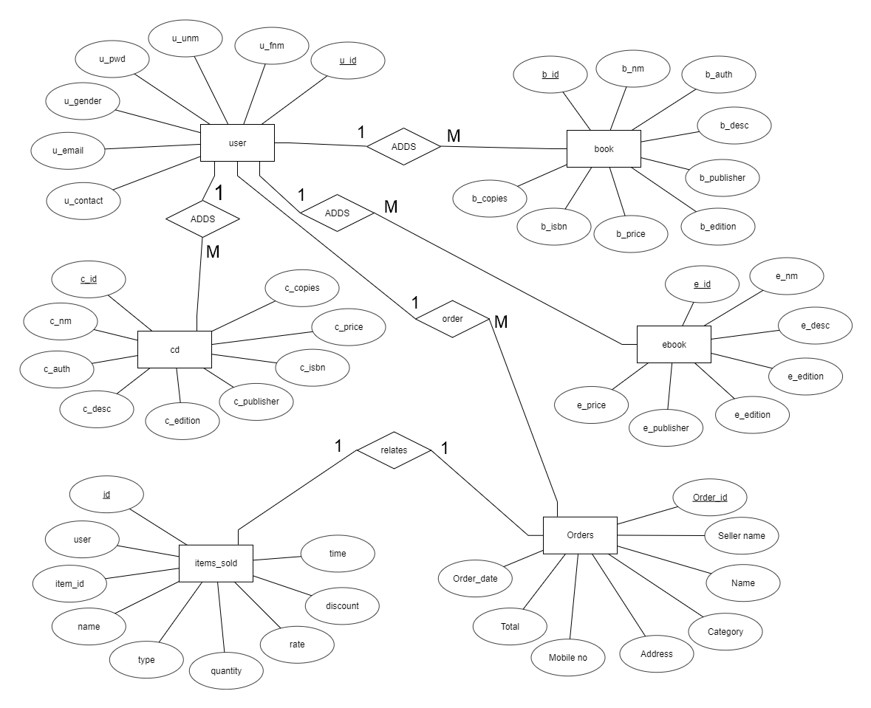

**ER Diagram**

1. ***SYSTEM DESIGN***

***Introduction:***

*System design is the solution of a “how to approach to the creation of the new system. It is composed of several steps. It facilitates the understanding and provides the procedural details necessary for implementation of the system recommended in the feasibility study. Emphasis is given on translating the performance requirements into design specification. Design goes through logical and physical stages of development.*

*Logical design reviews the present physical system; prepares input and output specification; make editing; security and control specification; details the implementation plan, and prepare logical design walk through. The physical design maps out the details of the physical system; plans the system implementation plan and specifies hardware and software. System design translates the system requirement into the ways of the system as recommended in the feasibility study. Thus the system design is the translation from user-oriented document to a programmer or a database personal oriented document. System design is a highly creative process that can be greatly facilitated by the following:-*

* *Strong Problem Definition*
* *Pictorial description of the Existing System*
* *Set of Requirements of the new system*

***Modules Description****:*

1. *Admin: Admin can add books, check orders and make sure the orders are delivered on time and can confirm payments by the customers.*
2. *Shopping Cart: Customers after login can browse through the different books and choose one or more products and can add them to cart.*
3. *Payment: Cash/Credit/Debit card is available.*

***3.2 INPUT DESIGN***

*Very careful attention had to be given to input design, which is a major part of the overall system design. In order to make the data entry as easy, logical and error free as possible, specific standards had been followed. Validation checks, provided in the system prevented the user in entering incorrect, erroneous data. This made sure that, only valid data had been available for data processing. If valid data was entered, then meaningful error messages had been prompted to enter correct data. The interactive screen formats facilitate the entry of valid data.*

***3.2.1 VALIDATIONS:***

*Some fields are having only number, as an I/P. For this key ASCII is checked. If they entered characters, it would display the message to enter number only. Exchange rates field will be validated for number and dot symbols.*

***3.2.2 INPUT DESIGN OBJECTIVES:***

*The numbers of clear objectives of input design are,*

* *To produce a cost effective method of input*
* *To achieve the highest possible level of accuracy*
* *To ensure that the input is acceptable to and understand by the user staff*

***3.3 OUTPUT DESIGN:***

*Output, as you probably know, generally refers to the results and information that are generated by the system. For many end-users, output is the main reason for developing the system and the basis on which they will evaluate the usefulness of the application. Most end users will not actually operate the information system or enter data through workstations, but they will use the output from the system.*

*When designing output, systems analysts must accomplish the following.*

* *Determine what information to present*
* *Decide whether to display, print, or “speak” the information and select the output medium.*
* *Arrange the presentation of information in an acceptable format.*
* *Decide how to distribute the output to intended recipients.*

*That alignment of information on a display or printed document is termed as layout.*

*Accomplishing the general activities listed above will require specific decisions, such as whether to use pre printed forms when preparing reports and documents, how many lines to plan on a printed page, or whether to use graphics and colour.*

*The output design is specified on layout performs, sheets that describe the location characteristics, and format of the column headings and pagination. As we indicated at the beginning of this discussion, these elements are analogous to an architect’s blue print that shows the location of the each component.*

***3.4 DATABASE DESIGN***

*The general theme behind a database is to handle information as an integrated whole. A database is a collection of inter-related data stored with minimum redundancy to serve single users quickly and efficiently. The general objective is to make information necessary, quick, inexpensive and flexible for the user.*

***Database Tables***

***Users Table***

|  |  |  |  |  |
| --- | --- | --- | --- | --- |
| ***Field Name*** | ***Data Type*** | ***Length*** | ***Allow Null*** | ***Constrain*** |
| *u_id* | *int* | *11* | *No* | *PK* |
| *u_fnm* | *varchar* | *35* | *No* |  |
| *u_unm* | *varchar* | *25* | *No* |  |
| *u_pwd* | *varchar* | *20* | *No* |  |
| *u_gender* | *varchar* | *7* | *No* |  |
| *u_email* | *varchar* | *35* | *No* |  |
| *u_contact* | *varchar* | *12* | *No* |  |
| *u_city* | *varchar* | *20* | *No* |  |

***Cd Table***

|  |  |  |  |  |
| --- | --- | --- | --- | --- |
| ***Field Name*** | ***Data Type*** | ***Length*** | ***Allow Null*** | ***Constrain*** |
| *cid* | *int* | *11* | *No* | *PK* |
| *name* | *varchar* | *40* | *No* |  |
| *author* | *varchar* | *35* | *No* |  |
| *des* | *varchar* | *75* | *No* |  |
| *edition* | *varchar* | *25* | *No* |  |
| *publisher* | *varchar* | *25* | *No* |  |
| *isbn* | *varchar* | *25* | *No* |  |
| *price* | *varchar* | *40* | *No* |  |

***Book Table***

|  |  |  |  |  |
| --- | --- | --- | --- | --- |
| ***Field Name*** | ***Data Type*** | ***Length*** | ***Allow Null*** | ***Constrain*** |
| *bid* | *int* | *11* | *No* | *PK* |
| *bname* | *varchar* | *60* | *No* |  |
| *author* | *varchar* | *50* | *No* |  |
| *des* | *longtext* | *0* | *Yes* |  |
| *publisher* | *varchar* | *40* | *No* |  |
| *edition* | *varchar* | *20* | *No* |  |
| *isbn* | *varchar* | *20* | *Yes* |  |
| *price* | *int* | *15* | *No* |  |
| *copies* | *varchar* | *400* | *No* |  |

***ebook Table***

|  |  |  |  |  |
| --- | --- | --- | --- | --- |
| ***Field Name*** | ***Data Type*** | ***Size*** | ***Allow Null*** | ***Constrain*** |
| *eid* | *int* | *11* | *No* | *PK* |
| *name* | *varchar* | *50* | *No* |  |
| *des* | *varchar* | *80* | *No* |  |
| *edition* | *varchar* | *40* | *No* |  |
| *publisher* | *varchar* | *20* | *No* |  |
| *price* | *varchar* | *10* | *No* |  |

***orders Table***

|  |  |  |  |  |
| --- | --- | --- | --- | --- |
| ***Field Name*** | ***Data Type*** | ***Size*** | ***Allow Null*** | ***Constrain*** |
| *orrderid* | *int* | *11* | *No* | *PK* |
| *sellername* | *varchar* | *40* | *No* |  |
| *name* | *varchar* | *40* | *No* |  |
| *selltype* | *varchar* | *40* | *No* |  |
| *category* | *varchar* | *40* | *No* |  |
| *Address* | *varchar* | *80* | *No* |  |
| *mobile* | *varchar* | *15* | *No* |  |
| *total* | *varchar* | *80* | *No* |  |
| *orderdate* | *timestamp* | *0* | *No* |  |

***items_sold Table***

|  |  |  |  |  |
| --- | --- | --- | --- | --- |
| ***Field Name*** | ***Data Type*** | ***Size*** | ***Allow Null*** | ***Constrain*** |
| *id* | *int* | *11* | *No* | *PK* |
| *user* | *varchar* | *40* | *No* |  |
| *itemid* | *varchar* | *40* | *No* |  |
| *name* | *varchar* | *40* | *No* |  |
| *type* | *varchar* | *80* | *No* |  |
| *quantity* | *varchar* | *15* | *No* |  |
| *rate* | *varchar* | *80* | *No* |  |
| *discount* | *varchar* | *30* | *No* |  |
| *time* | *timestamp* | *0* | *No* |  |

***5. IMPLEMENTATION AND TESTING***

***5.1 Implementation approaches***

*The Software Design Description Document has been used as input in the implementation process. The actual implementation has been done using PHP. PHP has been used to interact with the backend database. In this implementation, My SQL Server has been used as the backend RDBMS. PHP processes the inputs or commands given by the user and translates them in the commands understandable to the backend database. The output produced by the backend database is also handled by PHP which then displayed on the Browser screen.*

***Coding and Screenshots:***

*Index Page*

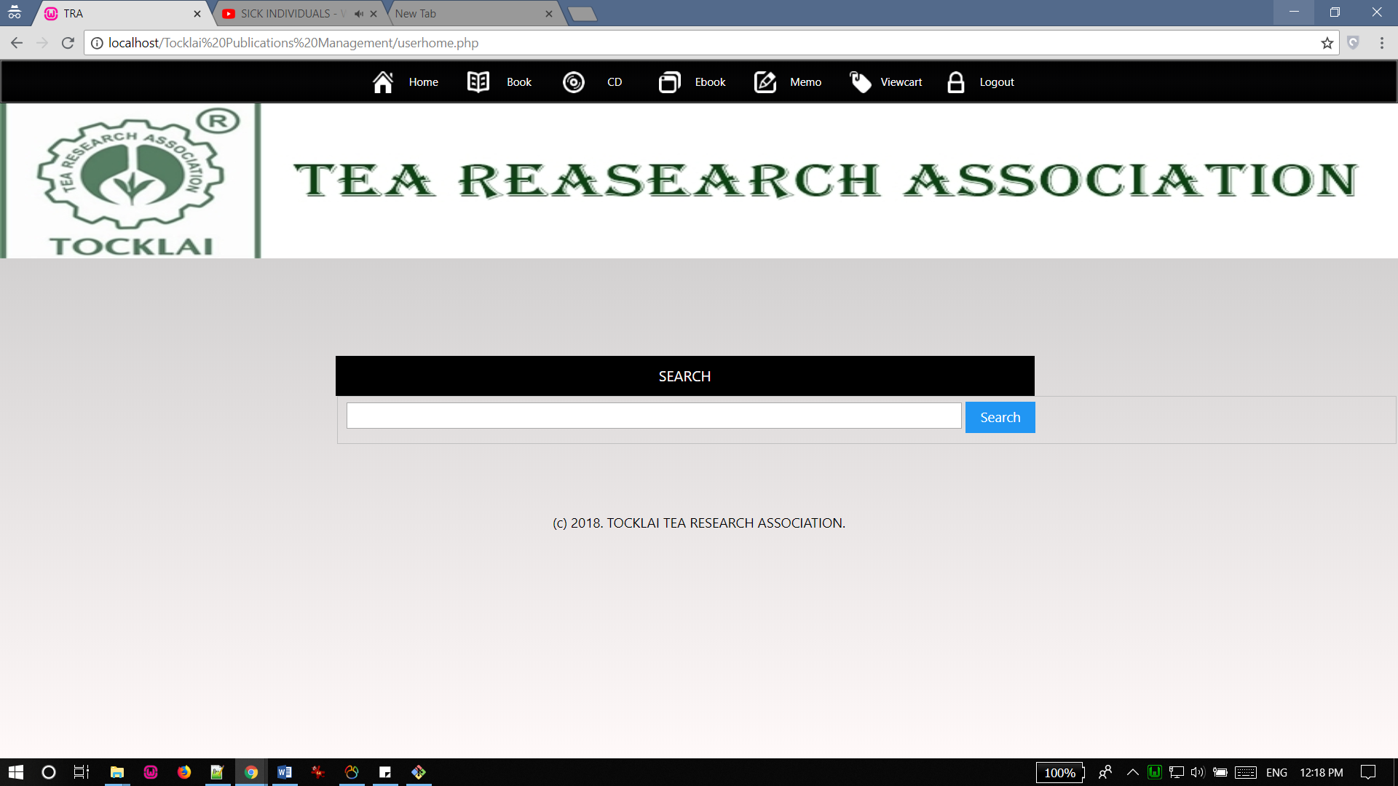

*Memo Page*

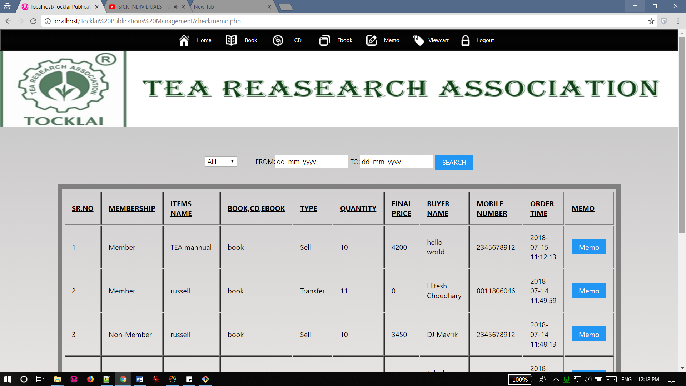

*Delivery Note Page*

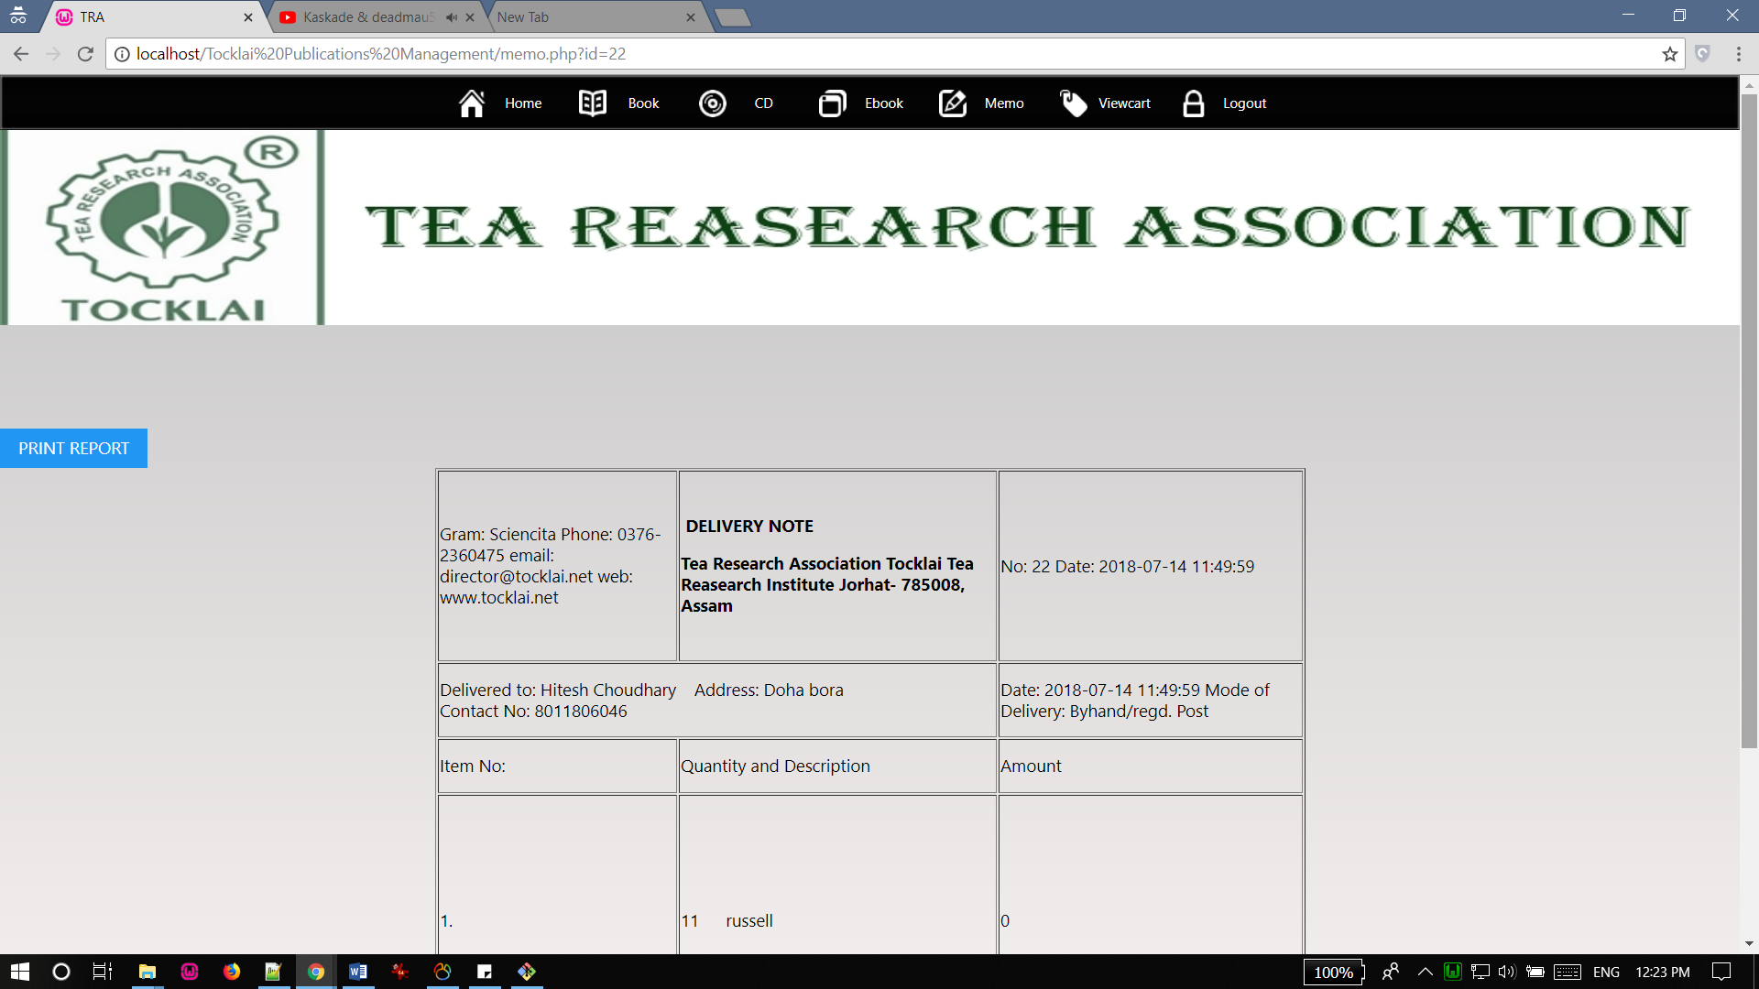

*Books Page*

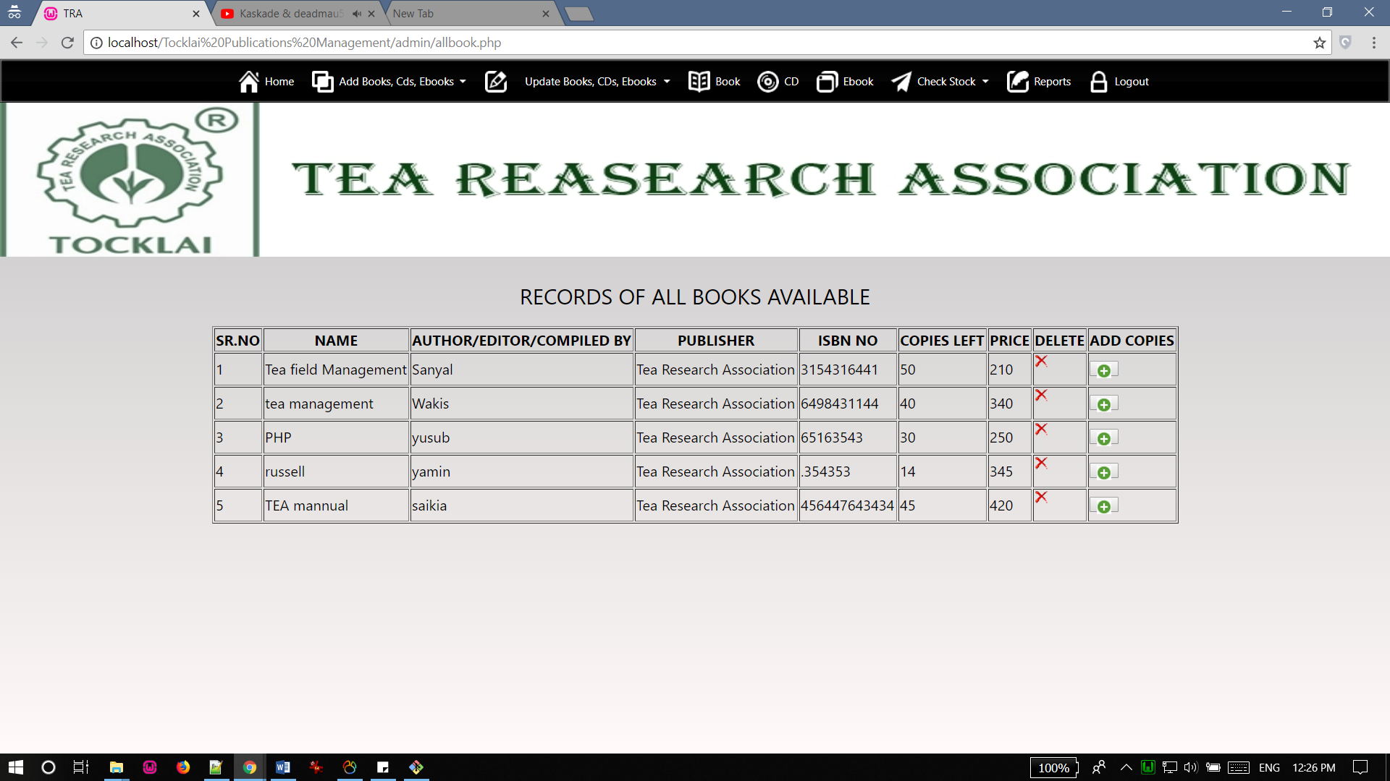

*Book Sale Report Page*

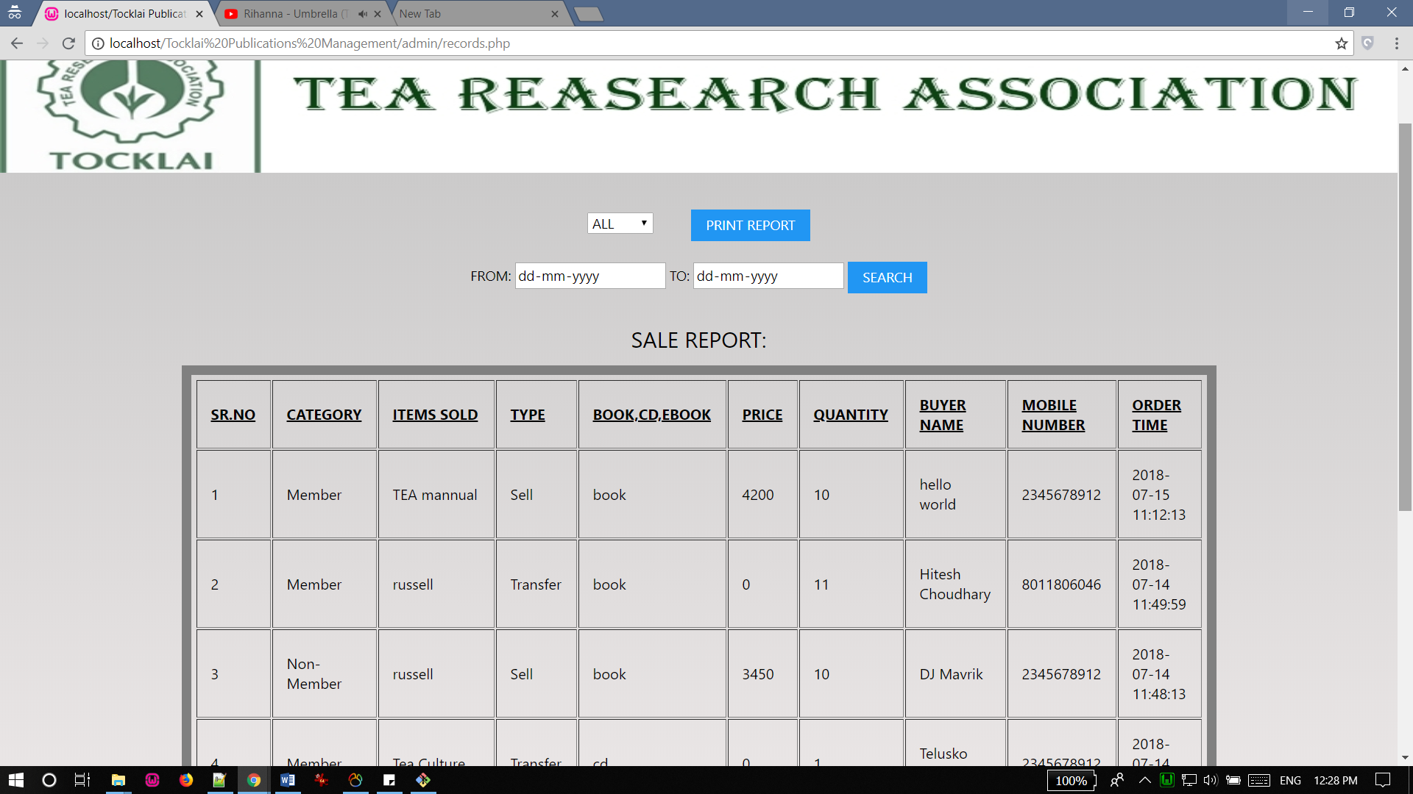

*Stock Report of Book Page*

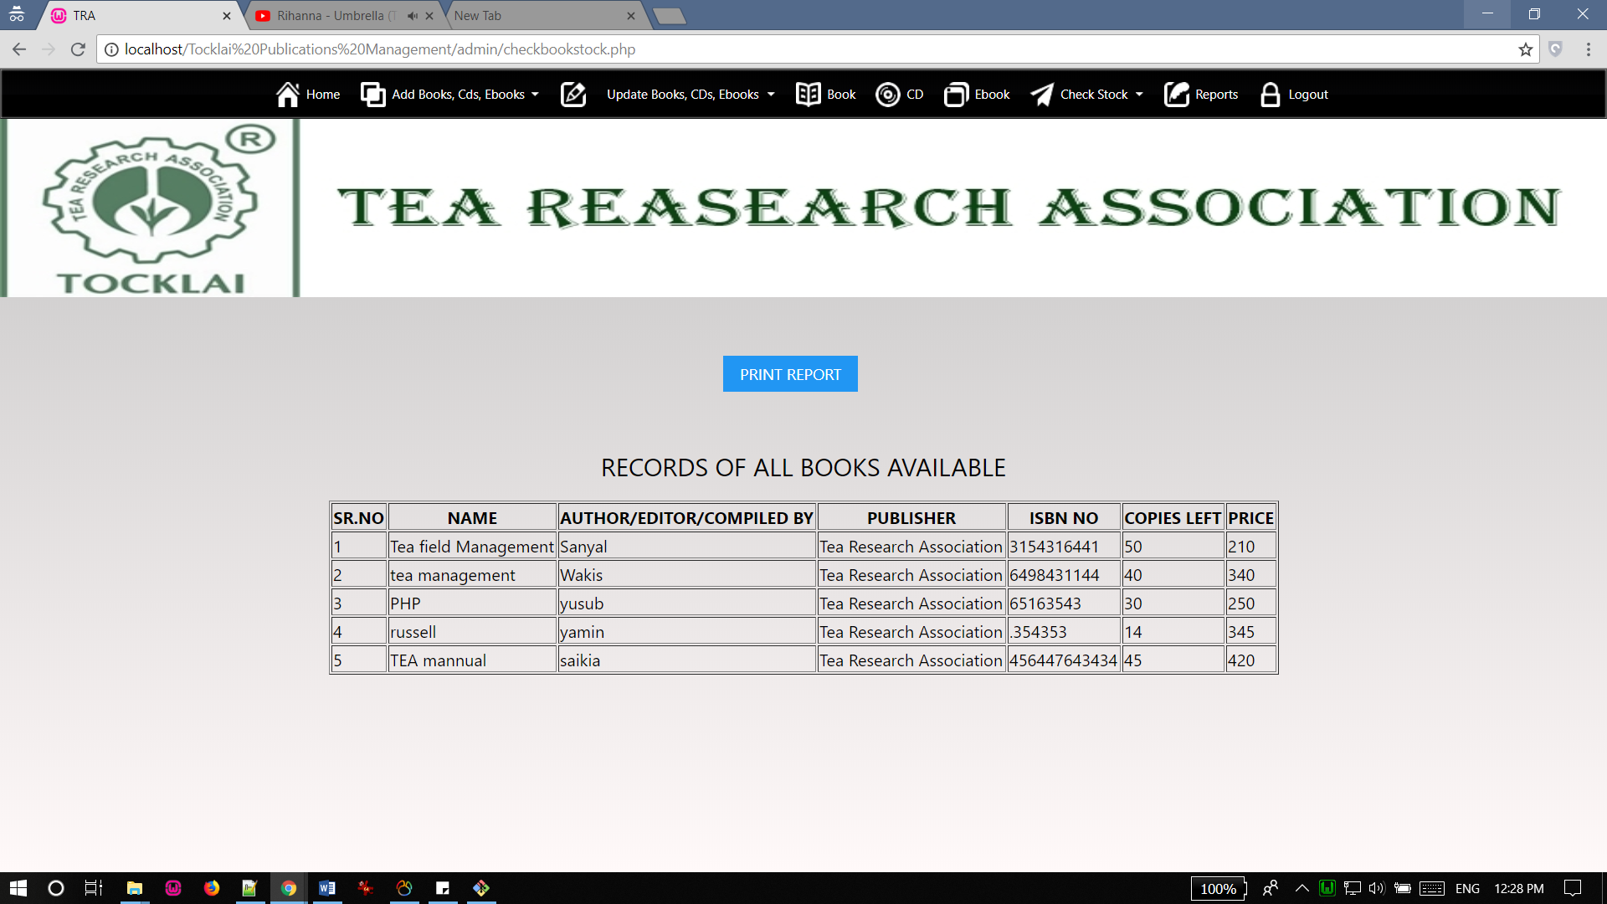

*Add book page*

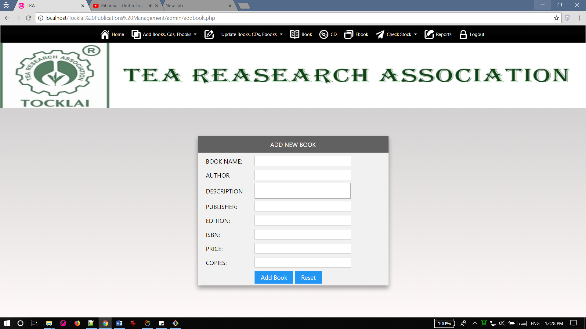

***Coding of index.php Page***

*<?php session_start();?>*

*<html>*

*<head>*

*<?php*

*include("includes/head.inc.php");*

*?>*

*</head>*

*<body>*

*<!-- start header -->*

*<?php*

*include("includes/menu.inc.php");*

*?>*

*<div id="logo">*

*<img src="images/headerlogo1.jpg" width="100%" height="170" alt=""/>*

*</div>*

*<!-- end header -->*

*<!-- start page -->*

*<div id="page">*

*<!-- start content -->*

*<div id="content">*

*<div class="post">*

*<h1 class="title">Welcome*

*<?php*

*if(isset($_SESSION['status']))*

*{*

*echo $_SESSION['unm'];*

*}*

*else*

*{*

*echo 'User';*

*}*

*?>*

*</h1>*

*<div class="entry">*

*<br><br>*

*</div>*

*</div>*

*</div>*

*<!-- end content -->*

*<!-- start sidebar -->*

*<div id="sidebar">*

*<?php*

*include("includes/search.inc.php");*

*?>*

*</div>*

*<!-- end sidebar -->*

*<div style="clear: both;">&nbsp;</div>*

*</div>*

*<!-- end page -->*

*<!-- start footer -->*

*<div id="footer">*

*<?php*

*include("includes/footer.inc.php");*

*?>*

*</div>*

*<!-- end footer -->*

*</body>*

*</html>*

***Coding of memo.php Page***

*<?php session_start();*

*?>*

*<!doctype html>*

*<html>*

*<head>*

*<meta charset="utf-8">*

*<title>TRA</title>*

*<style> #space*

*{*

*line-height:0.5cm;*

*}*

*</style>*

*<script>function myFunction()*

*{*

*var prt=document.getElementById("print");*

*var WinPrint=window.open('','','left=0,top=0,width=800,height=900,tollbar=0,scrollbars=0,status=0');*

*WinPrint.document.write(prt.innerHTML);*

*WinPrint.document.close();*

*WinPrint.focus();*

*WinPrint.print();*

*WinPrint.close();*

*setPageHeight("297mm");*

*setPageWidth("210mm");*

*setHtmlZoom(100);*

*//window.location.replace("index.php?query=");*

*}*

*</script>*

*</head>*

*<body><!-- start header -->*

*<?php*

*include("includes/menu.inc.php");*

*?>*

*<div id="logo">*

*<img src="images/headerlogo1.jpg" width="100%" height="170" alt=""/>*

*</div>*

*<!-- end header -->*

*<br><input type="button" class="a1-btn a1-green" value="PRINT REPORT" onclick="myFunction()">*

*<div id=print>*

*<?php*

*require('includes/config.php');*

*$id=$_GET['id'];*

*$sql= "Select * from orders o INNER JOIN items_sold i ON o.Order_Id=i.id Where i.id=$id";*

*$res=mysqli_query($conn, $sql);*

*$num=mysqli_num_rows($res);*

*for($x=1; $x<=$num;$x++)*

*{*

*$row=mysqli_fetch_array($res);*

*}*

*?>*

*<table id =space width="760" height="645" border="1" align="center">*

*<tr>*

*<td width="290" height="145">Gram: Sciencita Phone: 0376-2360475 email: director@tocklai.net web: www.tocklai.net</td>*

*<td width="493"><p><img src="LOGO-TRA_400x400.jpg" alt="" width="43" height="43" align="top"/>*

*<strong>DELIVERY NOTE</strong> </p>*

*<p><strong>Tea Research Association</strong> <strong>Tocklai Tea Reasearch Institute</strong> <strong>Jorhat- 785008, Assam</strong></p></td>*

*<td width="458">No: <?php echo $row['id']; ?> Date: <?php echo $row['Order_date']; ?></td>*

*</tr>*

*<tr>*

*<td height="56" colspan="2">Delivered to: <?php echo $row['Name']; ?> &ensp; Address: <?php echo $row['Address']; ?> <br> Contact No: <?php echo $row['Mobile Number']; ?> </td>*

*<td>Date: <?php echo $row['Order_date']; ?> Mode of Delivery: Byhand/regd. Post</td>*

*</tr>*

*<tr>*

*<td height="41">Item No:</td>*

*<td height="41">Quantity and Description</td>*

*<td>Amount</td>*

*</tr>*

*<tr>*

*<td height="192">1.</td>*

*<td height="192"><?php echo $row['quantity']." &ensp;&ensp; ".$row['name']; ?> </td>*

*<td><?php echo $row['Total']; ?> </td>*

*</tr>*

*<tr>*

*<td height="82" colspan="2"><p><strong>Received the above in good condition</strong></p>*

*<p>&nbsp;</p>*

*<p> <strong></strong>*

*<em>Signature of the buyer/buyers representative </em></p></td>*

*<td><p><strong>To be billed/Not to be billed</strong></p>*

*<p>&nbsp;</p>*

*<p> Signature of the Officer incharge*

*</p></td>*

*</tr>*

*</table>*

*</div>*

*</body>*

*</html>*

***Coding of records.php Page***

*<?php session_start();*

*if(!(isset($_SESSION['status'])))*

*{*

*header("location:../index.php");*

*}*

*require('includes/config.php');*

*$q="select * from items_sold order by id desc";*

*$res=mysqli_query($conn,$q) or die("Can't Execute Query...");*

*if(isset($_GET['first']) && isset($_GET['second']) && isset($_GET['type']))*

*{*

*$a=$_GET['first']." 23:59:59";*

*$b=$_GET['second'];*

*$c=$_GET['type'];*

*if($c=="all")*

*{*

*$q="select * from items_sold where (time between '$a' and '$b') or (time >='$b' and time <='$a') order by id desc";*

*$res=mysqli_query($conn,$q) or die($q);*

*}*

*else*

*{*

*$q="select * from items_sold where (time between '$a' and '$b') or (time >='$b' and time <='$a') and type='$c' order by id desc";*

*$res=mysqli_query($conn,$q) or die("Can't Execute Query...");*

*}*

*}*

*?>*

*<html>*

*<head>*

*<script>*

*function change()*

*{*

*var n=document.getElementById('type').value;*

*if(n=="all")*

*{*

*document.getElementById('all').style.display="block";*

*document.getElementById('book').style.display="none";*

*document.getElementById('ebook').style.display="none";*

*document.getElementById('cd').style.display="none";*

*}*

*else if(n=="ebook")*

*{*

*document.getElementById('all').style.display="none";*

*document.getElementById('book').style.display="none";*

*document.getElementById('ebook').style.display="block";*

*document.getElementById('cd').style.display="none";*

*}*

*else if(n=="book")*

*{*

*document.getElementById('all').style.display="none";*

*document.getElementById('ebook').style.display="none";*

*document.getElementById('book').style.display="block";*

*document.getElementById('cd').style.display="none";*

*}*

*else if(n=="cd")*

*{*

*document.getElementById('all').style.display="none";*

*document.getElementById('book').style.display="none";*

*document.getElementById('ebook').style.display="none";*

*document.getElementById('cd').style.display="block";*

*}*

*}*

*function myFunction()*

*{*

*var prt=document.getElementById("print");*

*var WinPrint=window.open('','','left=0,top=0,width=800,height=900,tollbar=0,scrollbars=0,status=0');*

*WinPrint.document.write(prt.innerHTML);*

*WinPrint.document.close();*

*WinPrint.focus();*

*WinPrint.print();*

*WinPrint.close();*

*setPageHeight("297mm");*

*setPageWidth("210mm");*

*setHtmlZoom(100);*

*//window.location.replace("index.php?query=");*

*}*

*function myFunction1()*

*{*

*var to=document.getElementById("to").value;*

*var fom=document.getElementById("from").value;*

*var n=document.getElementById('type').value;*

*if(to=="" || fom=="")*

*alert("Please select a range..");*

*else*

*{*

*window.location.replace("records.php?first="+to+"&second="+fom+"&type="+n);*

*}*

*}*

*</script>*

*<?php*

*if($_SESSION['unm']=="admin")*

*include("includes/head.inc.php");*

*else*

*include("../includes/head.inc.php");*

*?>*

*<style>*

*table{padding:5px;border:10px solid gray}*

*td,th{padding:15px}*

*</style>*

*</head>*

*<body>*

*<!-- start header -->*

*<?php*

*if($_SESSION['unm']=="admin")*

*include("includes/menu.inc.php");*

*else*

*include("menu/menu.inc.php");*

*?>*

*<div id="logo">*

*<img src="images/headerlogo1.jpg" width="100%" height="170" alt=""/>*

*<?php*

*if($_SESSION['unm']=="admin")*

*include("includes/logo.inc.php");*

*else*

*include("../includes/logo.inc.php");*

*?>*

*</div><br>*

*<!-- end header -->*

*<!-- start page -->*

*<div id="page">*

*<!-- start content -->*

*<center><select id="type" onchange="change()">*

*<option value="all">ALL</option>*

*<option value="book">BOOK</option>*

*<option value="ebook">EBOOK</option>*

*<option value="cd">CD</option>*

*</select>*

*&nbsp;&nbsp;&nbsp;&nbsp;&nbsp;&nbsp;&nbsp;&nbsp;*

*<input type="button" class="a1-btn a1-green" value="PRINT REPORT" onclick="myFunction()"><br><br>*

*<!--<button onclick="myFunction()">PRINT REPORT</button><br><br>-->*

*FROM:<input type="date" name="from" id="from" required>*

*TO:<input type="date" name="to" id="to" required>*

*<input type="button" class="a1-btn a1-green" value="SEARCH" onclick="myFunction1()"><br><br>*

*</center>*

*<div class="post" id="print">*

*<h1 class="title"></h1>*

*<div class="entry" id="all">*

*<table border='1' WIDTH='90%' align="center">*

*<h3 align="center">SALE REPORT:<h3>*

*<tr>*

*<td WIDTH='5%' style="color:darkgreen"><b><u>SR.NO</u></b></td>*

*<TD style="color:darkgreen" WIDTH='9%'><b><u>CATEGORY</u></b></TD>*

*<TD style="color:darkgreen" WIDTH='9%'><b><u>ITEMS SOLD </u></b></TD>*

*<TD style="color:darkgreen" WIDTH='7%'><b><u>TYPE</u></b></TD>*

*<TD style="color:darkgreen" WIDTH='6%'><b><u>PRICE</u></b></TD>*

*<TD style="color:darkgreen" WIDTH='8%'><b><u>QUANTITY</u></b></TD>*

*<TD style="color:darkgreen" WIDTH='9%'><b><u>FINAL PRICE</u></b></TD>*

*<TD style="color:darkgreen" WIDTH='9%'><b><u>BUYER NAME</u></b></TD>*

*<TD style="color:darkgreen" WIDTH='9%'><b><u>MOBILE NUMBER</u></b></TD>*

*<TD style="color:darkgreen" WIDTH='10%'><b><u>ORDER TIME</u></b></TD>*

*</tr>*

*<?php*

*$count=1;*

*while($row=mysqli_fetch_assoc($res))*

*{*

*$query = "Select * from orders where Order_Id='" . $row['id'] . "'";*

*$result=mysqli_query($conn, $query);*

*$row2=mysqli_fetch_assoc($result);*

*$tot=($row['rate']*$row['quantity'])-$row['discount'];*

*echo '<tr>*

*<td>'.$count.'*

*<td>'.$row2['Category'].'*

*<td>'.$row['name'].'*

*<td>'.$row['type'].'*

*<td>'.$row['rate'].'*

*<td>'.$row['quantity'].'*

*<td>'.$tot;*

*echo '</td>*

*<td>'.$row2['Name'].'*

*<td>'.$row2['Mobile Number'].'*

*<td>'.$row['time'];*

*echo '</tr>';*

*$count++;*

*}*

*?>*

*</TABLE>*

*</div>*

*<div class="entry" id="ebook" style="display:none;">*

*<table border='1' WIDTH='100%' align="center">*

*<tr>*

*<td WIDTH='10%' style="color:darkgreen"><b><u>SR.NO</u></b></td>*

*<TD style="color:darkgreen" WIDTH='50%'><b><u>CATEGORY</u></b></TD>*

*<TD style="color:darkgreen" WIDTH='50%'><b><u>ITEMS SOLD </u></b></TD>*

*<TD style="color:darkgreen" WIDTH='50%'><b><u>TYPE</u></b></TD>*

*<TD style="color:darkgreen" WIDTH='50%'><b><u>PRICE</u></b></TD>*

*<TD style="color:darkgreen" WIDTH='50%'><b><u>QUANTITY</u></b></TD>*

*<TD style="color:darkgreen" WIDTH='25%'><b><u>FINAL PRICE</u></b></TD>*

*<TD style="color:darkgreen" WIDTH='50%'><b><u>SELLER NAME</u></b></TD>*

*<TD style="color:darkgreen" WIDTH='20%'><b><u>BUYER NAME</u></b></TD>*

*<TD style="color:darkgreen" WIDTH='20%'><b><u>MOBILE NUMBER</u></b></TD>*

*<TD style="color:darkgreen" WIDTH='25%'><b><u>ORDER TIME</u></b></TD>*

*</tr>*

*<?php*

*$count=1;*

*$query2 = "Select * from items_sold where type='ebook' ORDER BY id DESC";*

*$result2 = mysqli_query($conn, $query2);*

*while($row=mysqli_fetch_assoc($result2))*

*{*

*$query = "Select * from orders where Order_Id='" . $row['id'] . "'";*

*$result=mysqli_query($conn, $query);*

*$row2=mysqli_fetch_assoc($result);*

*$tot=($row['rate']*$row['quantity'])-$row['discount'];*

*echo '<tr>*

*<td>'.$count.'*

*<td>'.$row2['Category'].'*

*<td>'.$row['name'].'*

*<td>'.$row['type'].'*

*<td>'.$row['rate'].'*

*<td>'.$row['quantity'].'*

*<td>'.$tot;*

*echo '</td>*

*<td>'.$row2['Seller Name'].'*

*<td>'.$row2['Name'].'*

*<td>'.$row2['Mobile Number'].'*

*<td>'.$row['time'];*

*echo '</tr>';*

*$count++;*

*}*

*?>*

*</TABLE>*

*</div>*

*<div class="entry" id="cd" style="display:none;">*

*<table border='1' WIDTH='90%' align="center">*

*<h3 align="center">SALE REPORT:<h3>*

*<tr>*

*<td WIDTH='10%' style="color:darkgreen"><b><u>SR.NO</u></b></td>*

*<TD style="color:darkgreen" WIDTH='50%'><b><u>MEMBERSHIP</u></b></TD>*

*<TD style="color:darkgreen" WIDTH='50%'><b><u>ITEMS SOLD </u></b></TD>*

*<TD style="color:darkgreen" WIDTH='50%'><b><u>TYPE</u></b></TD>*

*<TD style="color:darkgreen" WIDTH='50%'><b><u>PRICE</u></b></TD>*

*<TD style="color:darkgreen" WIDTH='50%'><b><u>QUANTITY</u></b></TD>*

*<TD style="color:darkgreen" WIDTH='25%'><b><u>FINAL PRICE</u></b></TD>*

*<TD style="color:darkgreen" WIDTH='20%'><b><u>BUYER NAME</u></b></TD>*

*<TD style="color:darkgreen" WIDTH='20%'><b><u>MOBILE NUMBER</u></b></TD>*

*<TD style="color:darkgreen" WIDTH='25%'><b><u>ORDER TIME</u></b></TD>*

*</tr>*

*<?php*

*$count=1;*

*$query2 = "Select * from items_sold where type='cd' ORDER BY id DESC";*

*$result2 = mysqli_query($conn, $query2);*

*while($row=mysqli_fetch_assoc($result2))*

*{*

*$query = "Select * from orders where Order_Id='" . $row['id'] . "'";*

*$result=mysqli_query($conn, $query);*

*$row2=mysqli_fetch_assoc($result);*

*$tot=($row['rate']*$row['quantity'])-$row['discount'];*

*echo '<tr>*

*<td>'.$count.'*

*<td>'.$row2['Category'].'*

*<td>'.$row['name'].'*

*<td>'.$row['type'].'*

*<td>'.$row['rate'].'*

*<td>'.$row['quantity'].'*

*<td>'.$tot;*

*echo '</td>*

*<td>'.$row2['Name'].'*

*<td>'.$row2['Mobile Number'].'*

*<td>'.$row['time'];*

*echo '</tr>';*

*$count++;*

*}*

*?>*

*</TABLE>*

*</div>*

*<div class="entry" id="book" style="display:none;">*

*<table border='1' WIDTH='90%' align="center">*

*<tr>*

*<td WIDTH='10%' style="color:darkgreen"><b><u>SR.NO</u></b></td>*

*<TD style="color:darkgreen" WIDTH='50%'><b><u>MEMBERSHIP</u></b></TD>*

*<TD style="color:darkgreen" WIDTH='50%'><b><u>ITEMS SOLD </u></b></TD>*

*<TD style="color:darkgreen" WIDTH='50%'><b><u>TYPE</u></b></TD>*

*<TD style="color:darkgreen" WIDTH='50%'><b><u>PRICE</u></b></TD>*

*<TD style="color:darkgreen" WIDTH='50%'><b><u>QUANTITY</u></b></TD>*

*<TD style="color:darkgreen" WIDTH='25%'><b><u>FINAL PRICE</u></b></TD>*

*<TD style="color:darkgreen" WIDTH='20%'><b><u>BUYER NAME</u></b></TD>*

*<TD style="color:darkgreen" WIDTH='20%'><b><u>MOBILE NUMBER</u></b></TD>*

*<TD style="color:darkgreen" WIDTH='25%'><b><u>ORDER TIME</u></b></TD>*

*</tr>*

*<?php*

*$count=1;*

*$query2 = "Select * from items_sold where type='book' ORDER BY id DESC";*

*$result2 = mysqli_query($conn, $query2);*

*while($row=mysqli_fetch_assoc($result2))*

*{*

*$query = "Select * from orders where Order_Id='" . $row['id'] . "'";*

*$result=mysqli_query($conn, $query);*

*$row2=mysqli_fetch_assoc($result);*

*$tot=($row['rate']*$row['quantity'])-$row['discount'];*

*echo '<tr>*

*<td>'.$count.'*

*<td>'.$row2['Category'].'*

*<td>'.$row['name'].'*

*<td>'.$row['type'].'*

*<td>'.$row['rate'].'*

*<td>'.$row['quantity'].'*

*<td>'.$tot;*

*echo '</td>*

*<td>'.$row2['Name'].'*

*<td>'.$row2['Mobile Number'].'*

*<td>'.$row['time'];*

*echo '</tr>';*

*$count++;*

*}*

*?>*

*</TABLE>*

*</div>*

*</div>*

*<!-- end content -->*

*<!-- start sidebar -->*

*<!-- end sidebar -->*

*<div style="clear: both;">&nbsp;</div>*

*</div>*

*<!-- end page -->*

*<!-- start footer -->*

*<div id="footer">*

*<?php*

*if($_SESSION['unm']=="admin")*

*include("includes/footer.inc.php");*

*else*

*include("../includes/footer.inc.php");*

*?>*

*</div>*

*<!-- end footer -->*

*</body>*

*</html>*

***Coding of addbook.php Page***

*<?php session_start();*

*require('includes/config.php');*

*?>*

*<html>*

*<head>*

*<?php*

*include("includes/head.inc.php");*

*?>*

*</head>*

*<body>*

*<!-- start header -->*

*<?php*

*include("includes/menu.inc.php");*

*?>*

*<div id="logo">*

*<img src="images/headerlogo1.jpg" width="100%" height="170" alt=""/>*

*</div>*

*<!-- end header -->*

*<!-- start page -->*

*<div id="page">*

*<!-- start content -->*

*<div id="content">*

*<div class="post" style="margin-left:100px">*

*<h1 class="title" >Add Book</h1>*

*<div class="entry" >*

*<form action='process_addbook.php' method='POST' enctype="multipart/form-data">*

*<br><b>Book Name:</b><br>*

*<input type='text' name='name' size='40' required>*

*<br><br>*

*<b>Description:</b><br>*

*<textarea cols="40" rows="6" name='description' required></textarea>*

*<br><br>*

*<b>Author/Editor/Compiled By:</b><br>*

*<input type='text' name='b_auth' size='40' required>*

*<br><br>*

*<b>Publisher:</b><br>*

*<input type='text' name='publisher' size='40' required>*

*<br><br>*

*<b>Edition:</b><br>*

*<input type='text' name='edition' size='40' required>*

*<br><br>*

*<b>ISBN No:</b><br>*

*<input type='text' name='isbn_no' size='40' required>*

*<br><br>*

*<b>Number of Copies:</b><br>*

*<input type='number' name='isbn' size='40' required>*

*<br><br>*

*<b>PRICE:</b><br>*

*<input type='number' name='price' size='40' required>*

*<br><br>*

*<input type='submit' value=' OK ' >*

*</form>*

*</div>*

*</div>*

*</div>*

*<!-- end content -->*

*<!-- start sidebar -->*

*<!-- end sidebar -->*

*<div style="clear: both;">&nbsp;</div>*

*</div>*

*<!-- end page -->*

*<!-- start footer -->*

*<div id="footer">*

*<?php*

*include("includes/footer.inc.php");*

*?>*

*</div>*

*<!-- end footer -->*

*</body>*

*</html>*

***Coding of addcd.php Page***

*<?php session_start();*

*require('includes/config.php');*

*?>*

*<html>*

*<head>*

*<?php*

*include("includes/head.inc.php");*

*?>*

*</head>*

*<body>*

*<!-- start header -->*

*<?php*

*include("includes/menu.inc.php");*

*?>*

*<div id="logo">*

*<img src="images/headerlogo1.jpg" width="100%" height="170" alt=""/>*

*</div>*

*<!-- end header -->*

*<!-- start page -->*

*<div id="page">*

*<!-- start content -->*

*<div id="content">*

*<div class="post" style="margin-left:100px">*

*<h1 class="title" >Add CD</h1>*

*<div class="entry" >*

*<form action='add_cd_db.php' method='POST' enctype="multipart/form-data">*

*<br><b>CD Name:</b><br>*

*<input type='text' name='name' size='40' required>*

*<br><br>*

*<b>Author:</b><br>*

*<input type='text' name='b_auth' required size='40'>*

*<br><br>*

*<b>Description:</b><br>*

*<textarea cols="40" rows="6" required name='description' ></textarea>*

*<br><br>*

*<b>Publisher:</b><br>*

*<input type='text' name='publisher' required size='40'>*

*<br><br>*

*<b>Edition:</b><br>*

*<input type='text' name='edition' required size='40'>*

*<br><br>*

*<b>Number of Copies:</b><br>*

*<input type='number' name='noc' required size='40'>*

*<br><br>*

*<b>PRICE:</b><br>*

*<input type='number' name='price' required size='40'>*

*<br><br>*

*<input type='submit' value=' OK ' >*

*</form>*

*</div>*

*</div>*

*</div>*

*<!-- end content -->*

*<!-- start sidebar -->*

*<!-- end sidebar -->*

*<div style="clear: both;">&nbsp;</div>*

*</div>*

*<!-- end page -->*

*<!-- start footer -->*

*<div id="footer">*

*<?php*

*include("includes/footer.inc.php");*

*?>*

*</div>*

*<!-- end footer -->*

*</body>*

*</html>*

***Coding of addebook.php Page***

*<?php session_start();*

*require('includes/config.php');*

*?>*

*<html>*

*<head>*

*<?php*

*include("includes/head.inc.php");*

*?>*

*</head>*

*<body>*

*<!-- start header -->*

*<div id="header">*

*<div id="menu">*

*<?php*

*include("includes/menu.inc.php");*

*?>*

*</div>*

*</div>*

*<div id="logo-wrap">*

*<div id="logo">*

*<?php*

*include("includes/logo.inc.php");*

*?>*

*</div>*

*</div>*

*<!-- end header -->*

*<!-- start page -->*

*<div id="page">*

*<!-- start content -->*

*<div id="content">*

*<div class="post" style="margin-left:100px">*

*<h1 class="title" >Add eBook</h1>*

*<div class="entry" >*

*<form action='add_ebook_db.php' method='POST' enctype="multipart/form-data">*

*<br><b>eBook Name:</b><br>*

*<input type='text' name='name' required size='40' required>*

*<br><br>*

*<b>Description:</b><br>*

*<textarea cols="40" rows="6" required name='description' ></textarea>*

*<br><br>*

*<b>Publisher:</b><br>*

*<input type='text' name='publisher' required size='40'>*

*<br><br>*

*<b>Edition:</b><br>*

*<input type='text' name='edition' required size='40'>*

*<br><br>*

*<b>PRICE:</b><br>*

*<input type='number' name='price' required>*

*<br><br>*

*<input type='submit' value=' OK ' >*

*</form>*

*</div>*

*</div>*

*</div>*

*<!-- end content -->*

*<!-- start sidebar -->*

*<!-- end sidebar -->*

*<div style="clear: both;">&nbsp;</div>*

*</div>*

*<!-- end page -->*

*<!-- start footer -->*

*<div id="footer">*

*<?php*

*include("includes/footer.inc.php");*

*?>*

*</div>*

*<!-- end footer -->*

*</body>*

*</html>*

***5.2 Code efficiency***

*Code efficiency has been achieved through proper validation using various methods in PHP coding. First no data can be added, viewed, edited and deleted to database without login or session. For this we have implanted session tracking techniques through PHP. Codlings have been used to validate various forms to ensure correct data should enter in database.*

***5.3 Testing Approach***

***TESTING PROCEDURES***

* ***Unit Testing:*** *A Unit corresponds to a form/class in the package. Unit testing focuses on verification of the corresponding form or class. In this level we have tested all our forms/classes individually. This testing includes testing of control paths, interfaces, local data structures, logical decisions, boundary conditions, and error handling. From this testing we were able to save, retrieve, update, delete and the search records on a table.*
* ***Integration Testing****: Integration testing is used to verify the combination of the software modules. In this level, we have tested by combining all unit tested forms into a subsystem. Here we found that the subsystems are performing well.*
* ***System Testing:*** *System testing is used to verify, whether the developed system meets the requirements.*
* ***Acceptance Testing:*** *Acceptance is the part of the project by which the customer accepts the product. The system under consideration is tested for user acceptance by constantly keeping in touch with the system users at time of developing and making changes whenever required.*

*We hope that after the acceptance testing the system will perform the best result for the organization. When modification will be made, we will use regression testing during the maintenance of the system.*

*The Software System delivered to the customer may undergo changes. Changes may be due to addition of new functional modules or performance enhancement .For this purpose proper maintenance of the system is must.*

***5.3.1 Unit Testing***

|  |  |  |  |  |
| --- | --- | --- | --- | --- |
| ***Test case Ref No*** | | ***TCT-001*** | | |
|  | |  |  | |
| *Functionality* | | *:* | *Log in to the System* | |
|  | |  |  | |
| *Expected outcome* | | *:* | *The user should not login to member’s area*  *. and some error message follow* | |
|  | | | | |
| *Step No.* | *Data Used* | | | *Actual Outcome* |
| *1.* | *Click on the log in button*  *without entering username or password* | | | *An alert message came to enter*  *username* |
| *2.* | *Click on the log in button*  *after entering some username leaving password field blank* | | | *An alert message came to enter*  *password* |
| *3.* | *Click on the log in button*  *after entering some password but leaving username field blank* | | | *An alert message came to enter*  *username* |
| *4.* | *Click on the log in button*  *after entering some wrong username but correct password* | | | *A message displayed on Log in*  *page about this* |

|  |  |  |  |  |
| --- | --- | --- | --- | --- |
| ***Test case Ref No*** | | ***TCT-002*** | | |
|  | |  |  | |
| *Functionality* | | *:* | *Enter valid Data for customer registration* | |
|  | |  |  | |
| *Expected outcome* | | *:* | *The user should not get register any record without filling all necessary fields and some error message follow*  *The user should not get registered again with same patient id* | |
|  | | | | |
| *Step No.* | *Data Used* | | | *Actual Outcome* |
| *1.* | *Click on the save button*  *without entering valid details* | | | *An alert message came to each*  *details and focused on the respective fields* |
| *2.* | *Click on the submit button*  *after entering a duplicate patient id* | | | *A message displayed about*  *existence of such patient* |

***6. RESULTS AND DISCUSSION***

***6.1 Test Reports***

|  |  |  |
| --- | --- | --- |
| *Test Case No* | *Date* | *Pass / Fail* |
| *TCT-001* | *11/5/2018* | *Pass* |
| *TCT-002* | *02/5/2018* | *Pass* |
| *TCT-003* | *25/5/2018* | *Pass* |

***6.2 DOCUMENTATION***

* + ***For Management***

*Online Shopping System is primarily designed for providing information from the data after processing them. This system is designed for supplying information to the strategic level of management from the operational control. It includes almost all the functional areas needed like keeping Employee Records Student Records and Fees Records.*

* + ***For User***

*With this electronic data processing system, the operators will able to maintain the following task:*

* + - *Information regarding Patients.*
    - *Records of Test Report with their details.*
    - *Regular Transaction Details*
  + ***For data processing department***
* *In maintenance, the data processing department needs to create backup of the database file from time to time.*
* *The main menu of the system provides different menus for different purposes.*

***7.1 CONCLUSION***

*After implementing the application it will contain the advantages were incomparable to the present contemporary systems used by company. The most admirable feature founded was its simplicity in terms of application to the user but its highly beneficial outputs can’t be ignored. The users will be highly benefited after using the system.*

*It is hoped that this project will help the future developers to modify and implement the system. After modifying some techniques of the programs, it will give us the best performance as our requirements. The project will be very useful for the users.*

***7.2 LIMITATION***

*Through, the proposed system has many useful features, it has some limitations also because availability of all the required software and hardware facility is more expensive and difficult process. Through the new system has no doubt many advantages and flexibilities, the system has some limitations as follows:*

* *Security and authentication is not considered (partially).*
* *Distribution aspect of information is ignored.*
* *The system has only a fixed number of queries for information processing.*

***7.3 FUTURE SCOPE***

*Software development is never –ending process and continues the life of the software as per the changing needs of the user from time to time. The project is no doubt has been developed keeping in mind easy modification and enhancement that may be required from time to time.*

*However, there are many scopes to modify this software. As because due to shortage of time, we here become unable to include many things. We are trying to cover all their existing system for sales return records of the items but due to shortage of time we become unable to include many things. Due to lake of time I here include none of them and a future scope one can develop these returns which are so much essential. Only with a little more doing it is possible to design the formats for those returns. Moreover, an on-line system will be more helpful to the organization. . With almost the same data with only a little modification an on-line system can be designed to fulfill their demands. All these can be considered to be future scope for this project.*

***8. BIBLIOGRAPHY***

* *Google Search*
* *Ej Media*
* *W3schools.com*
* *Tutorials Point*